Hampshire County Councillor Report – Calleva Division August 2024
Cllr Rhydian Vaughan MBE

Highways Information

Road Repair Update
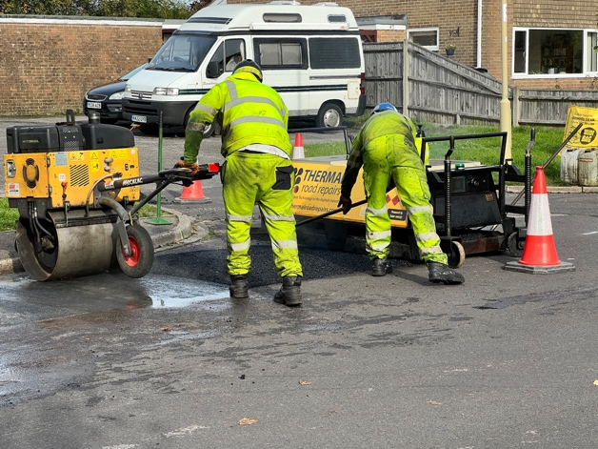
Hampshire County Council has been hard at work fixing potholes and road defects!

From April 2023 to April 2024, they delivered a whopping 180,909 repairs – a 37% increase from the previous year.

Potholes impact daily journeys for residents, whether commuting to work, heading to school, running a business, or exploring our beautiful county.

Thanks to an additional £22.5 million investment over two years, our highways service and main contractor, Milestone, have been able to deploy more resources to tackle these road issues promptly.

And Hampshire isn’t alone – colder, wetter winters take a toll on roads everywhere. Plus, inflation means it now costs taxpayers around 44% more to repair a pothole.

But fear not! Summer’s here, bringing drier, warmer days. Our highways teams are on it, fixing potholes, smoothing surfaces, and maintaining roads across the county.

Reporting Highway Problems

Links to report road issues are here:

Potholes: https://www.hants.gov.uk/transport/roadmaintenance/roadproblems/potholes

Tree/hedge problems:
https://www.hants.gov.uk/transport/roadmaintenance/roadproblems/treehedge

Flooding/drainage issues:
https://www.hants.gov.uk/transport/roadmaintenance/roadproblems/flooding

Pavement problems:
https://www.hants.gov.uk/transport/roadmaintenance/roadproblems/paving

Problems with rights of way:

https://www.hants.gov.uk/landplanningandenvironment/rightsofway/reportaproblem

When reporting an issue, you’ll be sent an email confirming a reference number for the report. If you would like me to follow this up for you then do please forward that message to me and I will chase for you

Increased housing targets for Hampshire

You might have noticed publicity about new housing targets for councils announced by Angela Rayner.

The figures for Hampshire are in the graphic below. The first column is the current housing target, the second is the number of houses delivered last year and the third is the new housing target released by the Government this week. You can see the increase proposed for B&DBC below.

I’m all in favour of new housing. , but new homes must be built in the right place, preserving local gaps; planned in consultation with local people; and crucially include high levels of local infrastructure.
In a letter Angela Rayner penned to council leaders this week she admitted that her new approach ‘will delay the adoption of some plans’. So much for getting on with delivery.

The enforced government delay is deeply concerning because we are obliged to provide a 5-year housing land supply. This means we need to show that we have a plan to deliver the next five years of housing meeting the Government’s target. So if our target is suddenely increased then we are unlikely to be able to meet it immediately and if we don’t, there is a huge risk of developers getting permission for speculative plans, which are unlikely to include the significant amount of new infrastructure we are demanding through the Local Plan process.

Of most concern is the fact that these new targets, introduced across both the county and the country, increase the amount of housing rural areas must deliver enormously.

Yet the numbers to be delivered by London and cities outside of the capital largely decrease. So much for the new Government’s insistence that new development should be delivered on brownfield and greyfield sites first.

The commonality between those areas with much increased targets? They are overwhelmingly councils controlled by Conservatives or Liberal Democrats. The areas with decreasing housing targets? Yes, largely Labour run. (Evidence the reduction in housing target for Labour controlled Southampton).
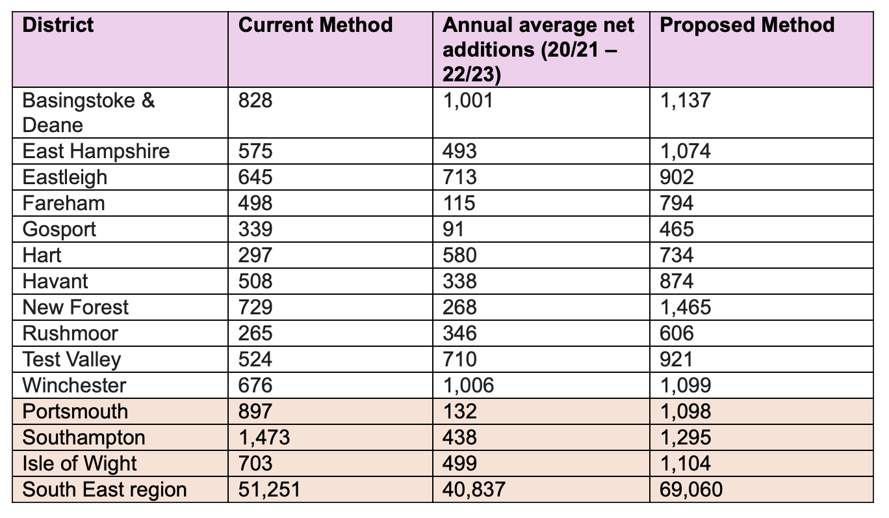
This is a really worrying precedent for the new Government, let’s hope their decision making is less partisan as it progresses.

Hampshire Country Parks this Summer

With the school holidays upon us there is loads to do at Hampshire County Council country parks and farms.

From bug hunts at Staunton and Queen Elizabeth Country Parks, to a Film Festival at Royal Victoria Country Park and a Seashore Safari at Lepe there are dozens of things to do, most particularly to keep your little ones occupied.

The general link to the country park and farm site is here: https://www.hants.gov.uk/thingstodo/countryparks/

Hampshire Archives Talks
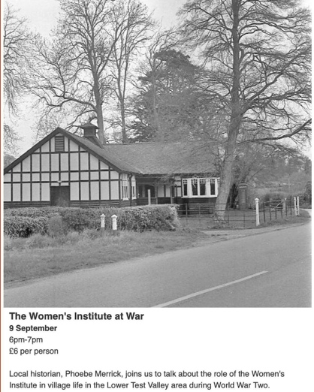
There's another fantastic event coming up from Archives - Hampshire County Council and Archives in a few weeks time.

Entitled 'The Women's Institute at War' this online talk is given by local historian Phoebe Merrick who will talk about how the WI contributed to the war effort in the villages of southern Test Valley.

The talk is on Monday 2nd September, from 6-7pm. It costs £6 per person and you can register for it here: https://www.hants.gov.uk/.../womens-institute-at-war-090924

Hampshire Childrens Services rated ‘Outstanding’

Supporting children and young people to get the best possible start in life and protecting those who are most vulnerable is one of our top priorities, so we’re pleased to share that our Children’s Services have once again been rated ‘Outstanding’ by Ofsted – the second time in a row.
Hampshire children and families who need extra help and protection continue to be supported by one of the few authorities in the country with outstanding rated Children’s Services. Our dedicated staff continue to make a positive difference, despite the backdrop of growing demand and complexity in the needs of children.
Learn more at https://www.hants.gov.uk/.../20240723outstandingofstedresult



Solent Co2 Pipeline Project - launch of consultation on proposed corridors

ExxonMobile are beginning to consult on early plans to create a pipeline to transport captured Co2 to storage facilities under the English Channel.

This would be a huge project, and one which has national infrastructure designation. Some of the proposals though would impact both the Waterside and the New Forest National Park considerably.

There are more details in the images below, including the locations and dates of information events which start on August 6th.

The description of the scheme says:

The Solent region is one of the largest and most successful industrial areas in the UK, supporting around 90,000 businesses, and a £50bn economy.

The Solent industries include Exxon Mobile's Fawley Manufacturing Complex and other areas such as power generation, shipping and manufacturing.

These industries produce essential products that we rely on every day.Carbon Capture and Storage (CCS) technology enables the delivery of a range of low carbon solutions with sufficient scale to decarbonise our site in Fawley and the industrial economy across the Solent region.

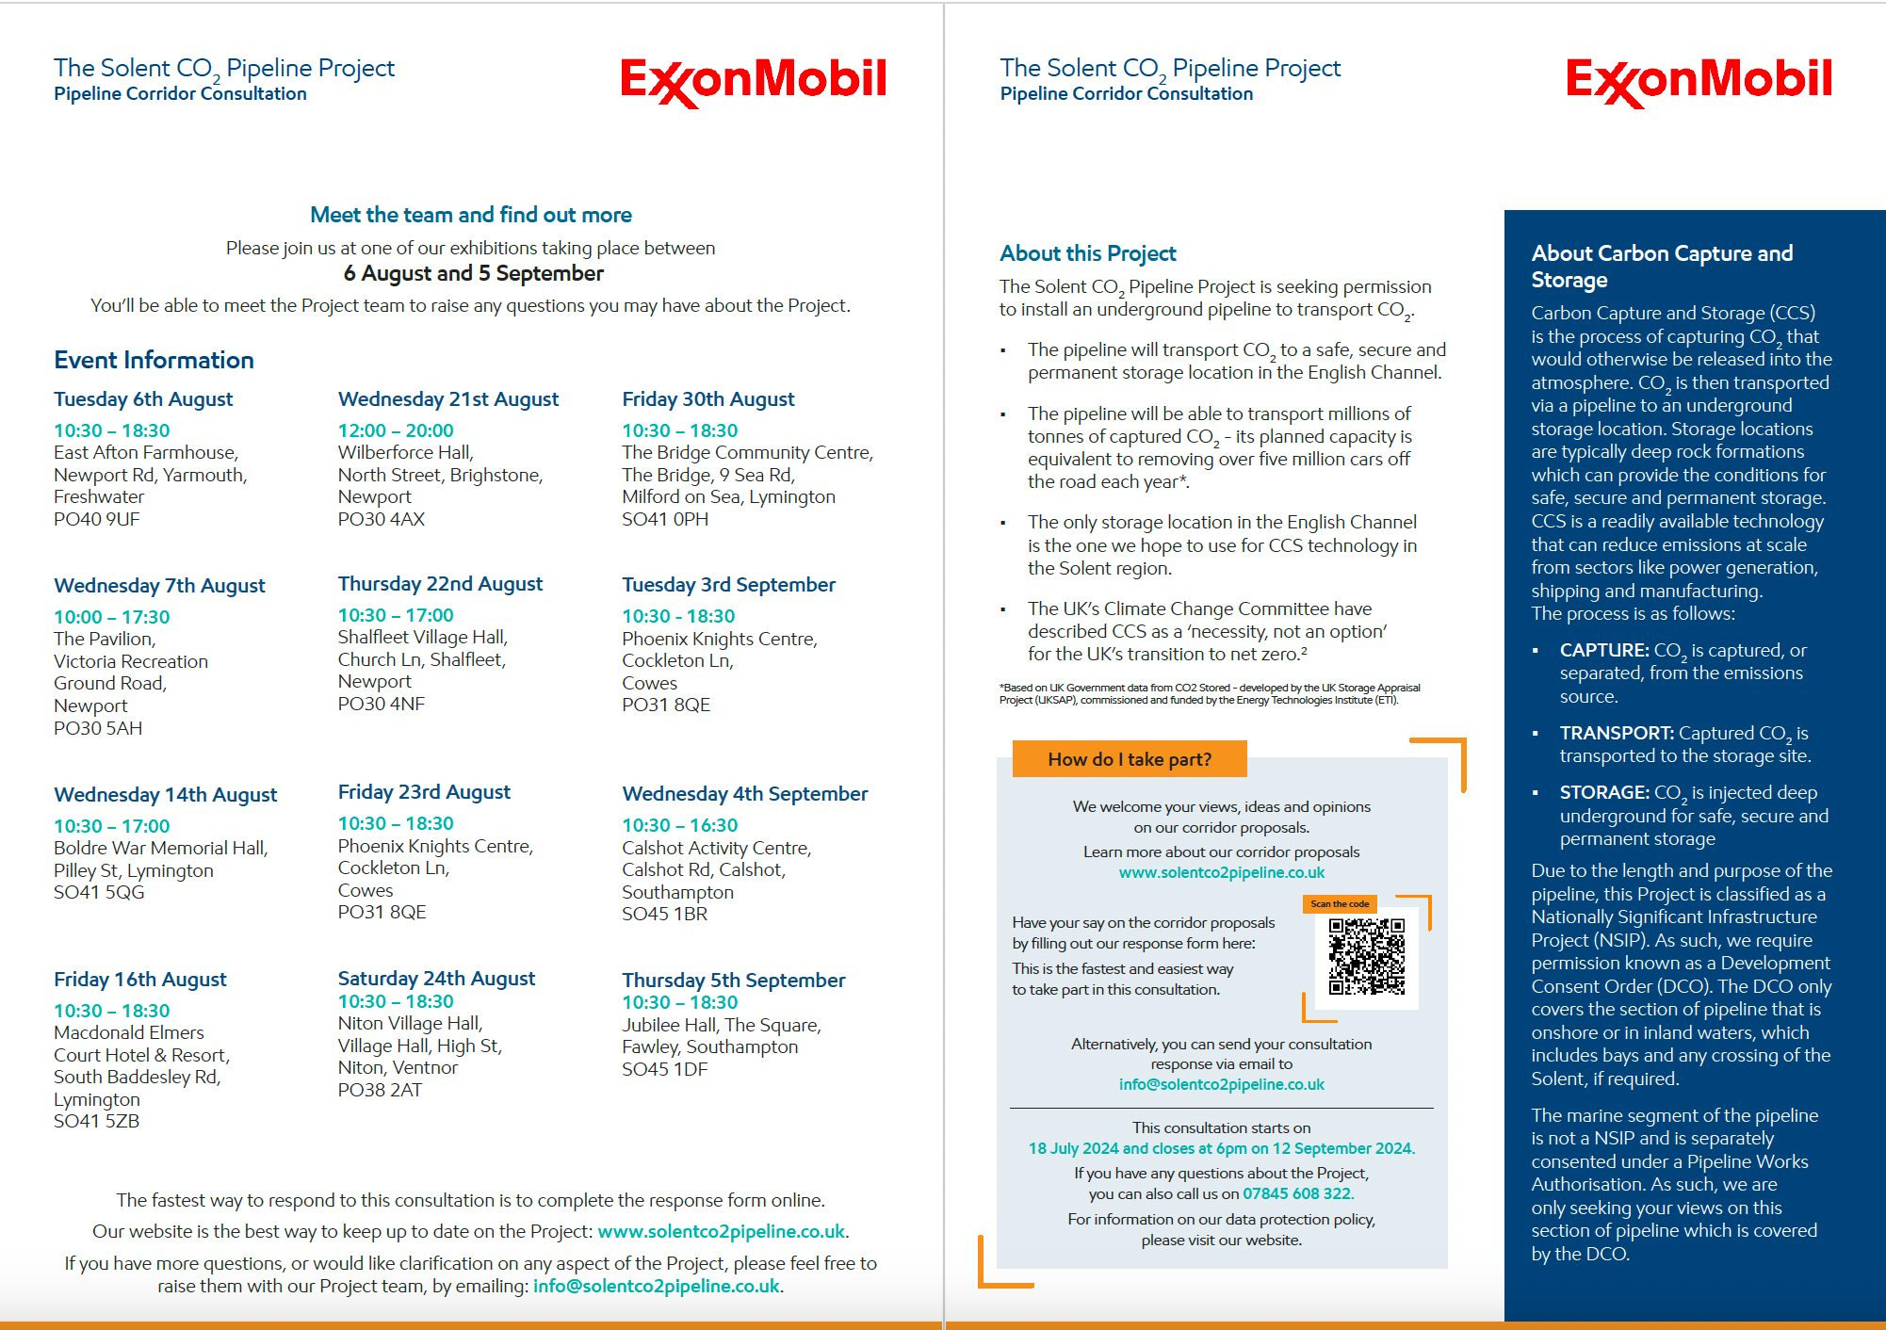

The Solent CO2 Pipeline Project is seeking permission to install an underground pipeline to transport captured Carbon Dioxide (CO2) to a safe, secure and permanent storage location in the English Channel.

