Hampshire County Councillor Update

Highways Information

Highways Updates:

From Lulu Bowerman, Cabinet Member for Highways and Waste

We know just how important roads, and specifically their condition, are to the people of Hampshire and we’re working hard to make them stronger – having invested extra funding so that we can make even more improvements to the 5,500 miles of roads that the County Council is responsible for.

The additional £22.5m investment over two years, on top of the £89m we typically spend annually to maintain the roads has so far enabled extra crews, equipment and materials to be brought in to repair even more road defects, like potholes, more quickly, as well as improve the surface quality of many more miles of road.

Latest data shows that between April and June this year, we’ve made good progress - having improved the surface of 345,655 square metres of road and repaired 18,505 road defects. And, with the autumn and winter weather in mind, 43,479 drains and gullies have also been cleared and cleaned, ready to cope with heavy rainfall. We’ll soon be starting our winter maintenance season (from 1 October) and, as with previous years, our highways crews will be ready day and night to spread salt on the main routes when freezing road surface temperatures are forecast, in order to keep Hampshire moving.

We know that work to make improvements to the roads can sometimes be inconvenient to road users, so we appreciate people’s patience as we keep up the momentum on this vital work.

We also wish to thank everyone who has reported road defects to us - such as potholes and other issues affecting the condition of the county’s roads. Please continue to do so, because when you report a road issue to us, it means we can act more quickly to fix the problem and make our roads stronger.

You can do this via the OurHants app (which can be downloaded from the Apple or Google play store) or online via the County Council’s website.

Highway Statistics, April – June
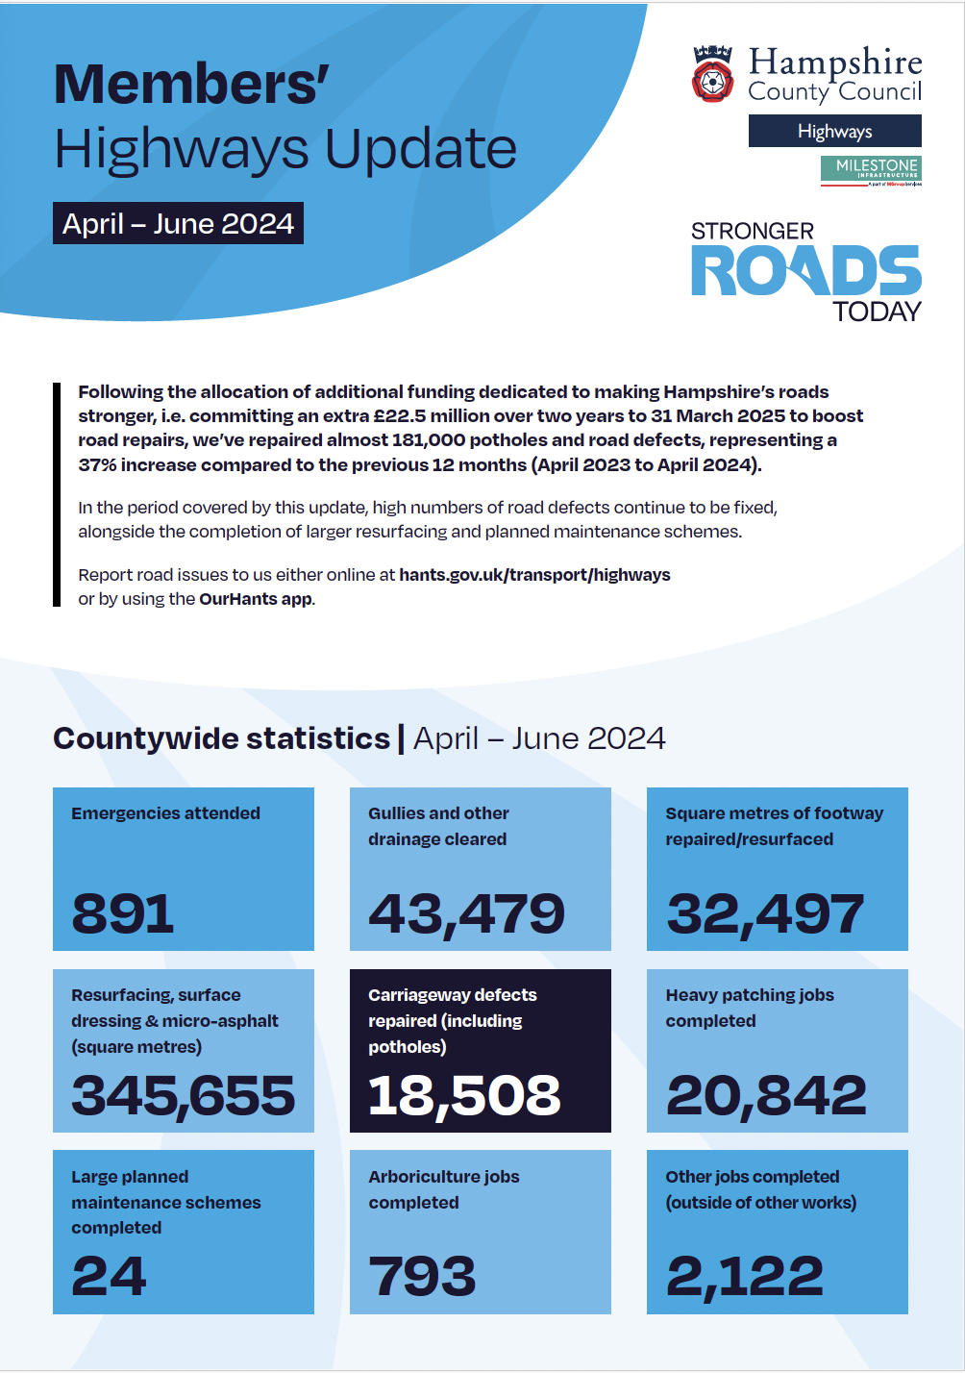

Reporting Highway Problems

Links to report road issues are here:

Potholes: https://www.hants.gov.uk/transport/roadmaintenance/roadproblems/potholes

Tree/hedge problems:
https://www.hants.gov.uk/transport/roadmaintenance/roadproblems/treehedge

Flooding/drainage issues:
https://www.hants.gov.uk/transport/roadmaintenance/roadproblems/flooding

Pavement problems:
https://www.hants.gov.uk/transport/roadmaintenance/roadproblems/paving

Problems with rights of way:

https://www.hants.gov.uk/landplanningandenvironment/rightsofway/reportaproblem

When reporting an issue, you’ll be sent an email confirming a reference number for the report. If you would like me to follow this up for you then do please forward that message to me and I will chase for you

HCC Flooding Toolkit

I’m delighted that the proposals for a community toolkit to assist Hampshire’s residents and communities identify the risk of, prepare for and mitigate the effect of flooding has been taken forward by Hampshire County Council.

We started this work when the exceptional rain last winter threatened flooding in many areas of the County. Great to see it now deliver in time for this autumn’s rains.

To help everyone across Hampshire, we’ve developed an online guide providing you with lots of information about flooding including which organisations have responsibility for flooding, your responsibilities as a property and/or landowner and advice on how to prepare for flood incidents. The new Community Toolkit can be downloaded from our website here https://www.hants.gov.uk/.../envir.../flooding/managing-risk

Use the links below for flood risk information and to sign up for alerts:

Check your flood risk for the next five days https://www.gov.uk/check-flooding

Sign up for flood warnings by phone, text or email https://www.gov.uk/sign-up-for-flood-warnings

Check your flood risk over a longer period from rivers, the sea, surface water, reservoirs and groundwater https://www.gov.uk/check-long-term-flood-risk

Call the Environment Agency's 24-hour Floodline on 0845 988 1188 to listen to recorded information on the latest warnings and predictions, or to speak to an operator for more general information.

Hampshire Chonicle’s Leader’s Column

My thanks to the Hampshire Chronicle and its group newspapers for publishing my opinion piece this week, which explains why Hampshire County Council is currently facing a financial challenge, and the action we are taking to address it.

"Let me be very clear: Hampshire County Council is not ‘going bust’. We project our finances several years ahead. This allows us to foresee and understand the challenges in balancing the budget and continuing to deliver the services we are legally required to provide.

We are committed to transparency. Unlike some other councils, we believe in being open and honest with our residents, explaining the situation and describing the steps we are taking to address it.

Why is there such a gap in our budget? The County Council has a legal responsibility to carry out certain functions. We cannot say ‘no’ if someone asks for support, and in many cases, we cannot means-test or ask for a contribution toward the cost of providing a service."

You can read the article here: https://www.hampshirechronicle.co.uk/news/24608305.hampshire-county-council-leader-says-not-going-bust

Parking Scam – warning

A warning from Test Valley Borough Council who have been made aware of a scam parking fine text message currently doing the rounds. The message says they have received a parking fine and includes a link to pay it.

The council does not issue Parking Penalty Charge Notices via text messages. Geniune fines are sent by post.

If residents receive one of these texts, they should not click the link or pay the fine. Instead, report the scam by forwarding the text for free to 7726, as advised by Action Fraud and the National Cyber Security Centre.

National Planning Policy Consultation Response

Hampshire County Council has responded to the Government’s proposals to change the National Planning Policy Framework. The response included the following concerns to proposed significant uplift in housing numbers in our area:

- Planning for homes must include supporting infrastructure.
- The proposed housing targets for Hampshire are overly ambitious.
- Environmental constraints cover 45% of Hampshire, affecting housing delivery.
- The annual target for new dwellings in Hampshire would increase from 5,884 to 10,071, which is considered excessive.
- The proposals and lack of transitional arrangements will have immediate impact on the 5-year land supply, undermining the plan-led system and resulting in speculative development.
- Collaboration between local authorities is crucial for meeting housing and employment needs. Strategic planning should align with existing local government boundaries.
- Improving the existing system of developer contributions is preferred over the new Infrastructure Levy.
- The shift towards active travel and sustainable transport planning is welcomed.
- The County Council supports the opportunity to more explicitly make the link between climate change adaptation and health and well-being.
- There should also be a stronger link between the built environment and natural environment and mental health and well-being.
- Planning policy should recognise the severity of air pollution as a public health issue.
- Strengthened policies on climate change are welcomed. Strategic planning can help mitigate and adapt to climate impacts.

DECISIONS DUE THIS AUTUMN ON FUTURE SERVICES

From areas such as household waste recycling centres and streetlights to library stocks and road maintenance, this autumn will see key decisions made on the future of some important County Council services delivered to Hampshire residents after April 2025

Decisions due this autumn on future services | Hampshire County Council (hants.gov.uk)

SCHOOLS CONSULTED AS HAMPSHIRE COUNTY COUNCIL PROPOSES CLOSURE OF EDUCATION CATERING SERVICE

Hampshire County Council is proposing to close its Education Catering service by 31 March 2026, and is consulting with schools and nurseries which use the service on two potential options to meet their catering needs in future

Schools consulted as Hampshire County Council proposes closure of Education Catering service | Hampshire County Council (hants.gov.uk)

DON’T FORGET TO APPLY FOR SECONDARY PLACES BEFORE HALLOWEEN’S WITCHING HOUR

Parents and carers, it’s time to apply for your child’s secondary school place for September 2025

Don’t forget to apply for secondary places before Halloween’s witching hour | Hampshire County Council (hants.gov.uk)

BUILDING A STRONGER CONSTRUCTION SECTOR IN HAMPSHIRE – MENTORING PROVES KEY TO SUCCESS

Hampshire County Council is successfully helping more adults to stay in construction industry jobs across the county – overtaking the national average – and filling the sector’s skills shortage as well as boosting employment levels and the local economy

Building a stronger construction sector in Hampshire – mentoring proves key to success | Hampshire County Council (hants.gov.uk)

MAKING HAMPSHIRE HEALTHIER BY 2050

People living in Hampshire should enjoy better health as well as see more effective use of health services and the local economy boosted, by the year 2050 – that’s the pledge of key bodies across Hampshire

Making Hampshire healthier by 2050 | Hampshire County Council (hants.gov.uk)

HAMPSHIRE EXPANDS THE NUMBER OF SCHOOL PLACES FOR CHILDREN WITH SPECIAL EDUCATIONAL NEEDS

More children with Special Educational Needs and Disabilities (SEND) are set to benefit from local specialist school places as Hampshire County Council increases the provision at two schools in Fareham and the New Forest, as well as a nursery in Gosport. Most of the 31 new places at Heathfield Special School, Pennington Church of England Junior School, and Haven Nursery School will be available immediately

Hampshire expands the number of school places for children with special educational needs | Hampshire County Council (hants.gov.uk)

MOVE EVERY DAY FOR A FITTER AND HEALTHIER OLD AGE

Let’s get Able like Mabel and Steady like Eddie! That’s the message from Hampshire County Council to motivate older residents to do some strength building activity every day – even just a little – for a fitter later life and to help maintain balance and prevent falls

Move every day for a fitter and healthier old age | Hampshire County Council (hants.gov.uk)

HAMPSHIRE’S HEALTH AND WELLBEING THE FOCUS OF NEW COUNTY COUNCIL CABINET ROLE

A new position within Hampshire County Council’s Cabinet has been announced with dedicated responsibility for the public’s health and wellbeing across Hampshire County Council

Hampshire’s health and wellbeing the focus of new County Council Cabinet role | Hampshire County Council (hants.gov.uk)

NATIONAL INCLUSION WEEK: COUNTY COUNCIL SEEKS VIEWS FOR INFORMING SERVICES FOR CHILDREN AND YOUNG PEOPLE WITH SEND

A new informal consultation is seeking the views of young people with special educational needs and disabilities (SEND), their families and the professionals who work with them, in a bid to improve SEND services and participation opportunities in Hampshire

National Inclusion Week: County Council seeks views for informing services for children and young people with SEND | Hampshire County Council (hants.gov.uk)

CHECK YOUR FLOOD RISK AHEAD OF WINTER RAINFALL

Around 400,000 households in Hampshire are at risk of flooding and with the potential for increased rainfall because of climate change, particularly during autumn and winter, Hampshire County Council has created a new online tool to help people check their flood risk to help protect homes, land and businesses

Check your flood risk ahead of winter rainfall | Hampshire County Council (hants.gov.uk)

