Hampshire County Councillor Update – Calleva Division January 2025

Highways Information

Salting routes
When Hampshire County Council report Salting updates they sometimes also mention domains (North, Central, and South). We are North.

HCC may salt in one, two or all of the domains, and may also go out at different times.
Below is a map of the domains.

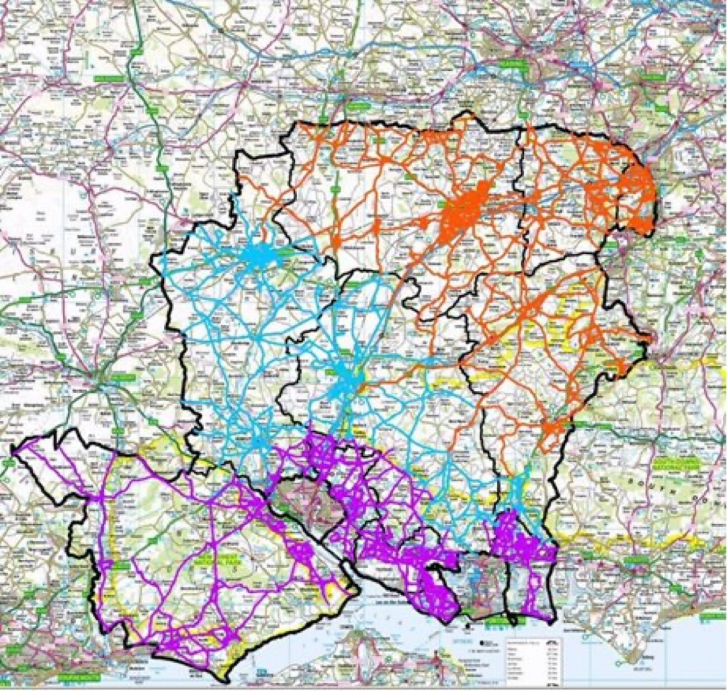

Salt Bins

HCC's network of blue and yellow community salt bins have been refilled ready for the coming months, making salt freely available for anyone to spread on local roads and pavements – useful to ‘join up’ with the salting on main roads by our gritters.

A little salt goes a long way, you’ll only need one tablespoon to treat up to a square metre of road or pavement.

If you’re able to, salting your local roads when it’s forecast to be icy can be a big help for your community, reducing the risk of incident and injury, especially for those who are less mobile.
You can report salt bins needing re-filling, those that are damaged or request one for your area here: https://www.hants.gov.uk/transport/highways/report-a-problem

Reporting Highway Problems

Links to report road issues are here:

Potholes:https://www.hants.gov.uk/transport/roadmaintenance/roadproblems/potholes

Tree/hedge problems:
https://www.hants.gov.uk/transport/roadmaintenance/roadproblems/treehedge

Flooding/drainage issues:
https://www.hants.gov.uk/transport/roadmaintenance/roadproblems/flooding

Pavement problems:
https://www.hants.gov.uk/transport/roadmaintenance/roadproblems/paving

Problems with rights of way:

https://www.hants.gov.uk/landplanningandenvironment/rightsofway/reportaproblem

When reporting an issue, you’ll be sent an email confirming a reference number for the report. If you would like me to follow this up for you then do please forward that message to me and I will chase for you.

Devolution and Local Government Reorganisation – A message from the Leader of HCC, Cllr Nick Adams-King

We are on the brink of a transformative journey for Hampshire, and the vehicle driving us forward is devolution. Our goal is a Hampshire & Solent where decisions, big and small, are made close to the people they affect; where less bureaucracy means quicker, simpler processes; and where councils can deliver even better value for money to residents and businesses.

There has been much discussion recently about the prospect of devolution for, and local government reorganisation in, Hampshire. I therefore wanted to provide you with some clarity about the current situation.

I believe devolution would be a beneficial move for Hampshire. Devolution means moving powers, and the money to enact them, from Central Government to a more local level. These powers would be devolved to a Combined Authority, in our case covering Hampshire and the Solent (including Southampton, Portsmouth, and the Isle of Wight), overseen by an elected mayor. The new government wants us to be one of their priority areas, targeting implementation by May 2026..

While I welcome devolution I have strong concerns about Local Government Reorganisation, which the Labour Government is closely linking to the devolution process.

Let me be clear, this journey is one the Labour Government is requiring Hampshire to take. There is no alternative, and I liken it to travelling in a vehicle where the Government controls the accelerator and the brakes, better therefore that we have control of the steering wheel rather than leave the route and destination to chance

It’s crucial for the County Council to have a strong voice in these discussions to represent our residents’ interests. A Full Council meeting has been called for 9th January to decide the best way forward, with Cabinet ratification of the Council’s decision the following day. If we proceed with the priority list, the government will determine by late January whether the 2025 County elections will be postponed.

Why would elections be postponed? The Government must carry out a full consultation on their devolution proposals. They aim to complete this and conclude any negotiations by Summer. The uncertainty of an election, and the inability to complete a consultation during the pre-election period, would disrupt the consultation and negotiation process too greatly. Hence, the Government expects those on the Priority Programme to request their elections be postponed.

If Hampshire is accepted as a priority area, we will need to submit our proposals for new Council areas by the autumn. If we do not enter the priority programme, then the Government expects proposals for new Councils to be submitted by May.

Before Christmas local leaders met with Local Government Minister Baroness Taylor and several important principles were clarified:

• The size of new Unitary authorities: populations of at least 500,000 but less than 1.2 million: Hampshire is too large to become a single unitary authority.
• Southampton and Portsmouth must expand and cannot remain unchanged.
• Existing district and borough boundaries should be retained as much as possible when creating new Unitary Councils.
• A decision on the proposed way forward must be submitted to the Government by January 10, 2025.

As this situation evolves, I am clear the focus must be on ensuring reforms deliver benefits such as:

• cost reductions for residents,
• service protection and simplification, and
• safeguarding frontline staff.

Councils across Hampshire employ thousands of staff and contract with thousands more partners and businesses, all of whom rely on us for their livelihoods. More importantly, tens of thousands of people rely on their local Council for support and assistance. These people must be at the forefront of our decision-making. We should and must only move forward with reform if the outcome for our residents is an improvement on the services and support they currently receive.

While devolution presents a promising path forward for Hampshire, it’s essential to navigate the
associated local government reforms carefully, ensuring they truly benefit the residents and communities they aim to serve.

I remain positive and hopeful as we enter this New Year, the path ahead is difficult and full of challenge. Working alongside my colleagues of all political colours I am sure we will, together, find the best way forward, one that will result in a positive improvement for all of us who live in our wonderful County.

Devolution & Local Government Reform – the options open to us.

In addition to the above, this note hopefully helps explain the options open to the County Council when we make our decision later this week:

There are three options before us:

- We agree to progress devolution (the elected mayor and creation of a Combined Authority) in order that it can be introduced in April 2026 with the mayoral election in May 2026. We would have to postpone this year’s elections in order for the necessary processes to be completed in time, as a pre election period would take too much time out of the schedule to enable the process of consulting on, negotiating, drafting and passing the legislation in Parliament and establishing the Combined Authority itself to be completed in a year.

We then have to submit our plans for new unitary councils by the ‘autumn’, this is undefined by Government but we assume this means the end of the year.

- We agree to progress Local Government Reform (LGR) as a priority, agreeing to submit new Council proposals by September at the latest. These would be established by 2026 with it being likely we would have elections to ‘Shadow’ authorities, (the new Councils we would have to create – electing councillors who could begin the process of setting up, creating administrations and hiring senior staff for them) in May 2026 and elections to the new Councils which would be fully created in May 2027.

Again we would postpone elections to allow for the process of consulting on, negotiating, drafting and passing the legislation in Parliament and establishing the plans for new Councils to be completed in a year.

Devolution would then follow, with a mayor being elected in 2027 or 2028.

- We don’t agree to either of these paths. In which case the Government want plans for the new councils lodged by September and, if we do not do that, then they will create the proposals for new Councils themselves and progress with those plans. Probably for elections in 2027 and 2028. In this scenario the elections in May go ahead.

I think devolution is a good thing. It brings power and money from Government and provides a strategic over-view helpful to the entire area.

I am much more concerned about local government reorganisation, particularly if we have to create unitary councils of over 500,000 population. They will be remote from people and we will lose much of the good things both the districts and the county currently do.

So that’s why I think Option 1 is the best. It gives us the main prize – devolution. It gives us the longest to think about how LGR might work. And because we would therefore be amongst the last having to submit our plans it might well mean we are at the back of the queue for that reorganisation increasing the chances that we eventually shape new Councils much more in keeping with what we think would work for Hampshire – smaller than 500,000, more centred on the areas people recognise as their ‘home community’.

Doing nothing is not an option. Doing nothing in fact brings a much greater chance that we will be ‘done unto’. The doing nothing option does include our holding elections this year rather than next, however for me the risks associated with that course are too great.

Thank you.

Hampshire County Council Enhances School Meal Provision!

You might have read some scare-mongering from opposition parties about Hampshire County Council cutting the provision of school meals.

The truth is quite the opposite, HCC is set to improve the quality and efficiency of school meals by transitioning to a new managed outsource arrangement by March 2026. This move will see meals sourced from alternative providers, potentially lowering costs for schools and families amidst ongoing cost-of-living pressures.

Key Highlights:

Cost Savings: Schools and families may benefit from lower meal prices.
Continued Access: School meals will remain available to all children, including those eligible for free meals.
Positive Feedback: 73% of consulted schools and nurseries are interested in this new arrangement.
Support for Schools: The Council will manage meal supply, easing the burden on schools.

This change aims to provide a more sustainable and affordable solution for school meals.

Expanding Special Educational Need provision in Hampshire

The number of children identified as having Special Educational Needs in Hampshire has been rising steadily in the last few years. The County Council is receiving on average 200 new Education Health and Care Plan (EHCP) applications every month. Meeting this growing need is therefore a priority for us.

So, Hampshire County Council is proposing to expand specialist school places for children with Special Educational Needs and Disabilities (SEND) at two mainstream schools in the New Forest and Havant.

Following initial consultations with parents, residents, and stakeholders, we're moving to a formal consultation on these proposals, which will be published on our website in late December.

By the end of this decade, the number of children in Hampshire with Education, Health, and Care Plans could increase by over 11,000, reaching around 28,000. Every new specialist school place we create is crucial.

Proposed Expansions:

Bartley Church of England Junior School, New Forest: 12 extra places for pupils with Social, Emotional, and Mental Health (SEMH) needs, opening in phases from September 2025.

Crookhorn College, Havant: 15 extra places for pupils with Autism Spectrum Condition (ASC), opening in phases from September 2025.

These proposals follow a recent decision to consult on 32 additional specialist places at schools in Gosport, Eastleigh, and the New Forest.

Currently, many children needing specialist support attend independent schools, which is costly. If agreed, the new places at Bartley and Crookhorn will cost £568,796 annually, compared to £1.9 million for the same number of places in independent schools.

**Hampshire County Council is making incredible strides in improving our environment and the fight against climate change!** 

Last month HCC's Cabinet heard about some of the amazing initiatives and achievements that are helping to create a greener, more sustainable future for all.

Here are some highlights:

**Solar Together Scheme**: Over 550 households have joined our third Solar Together scheme, generating their own green electricity. Combined with previous schemes, this will reduce CO2 emissions by more than 59,000 tonnes over the next 25 years!

**Repair Cafés**: By repairing worn-out or mechanically failing items, our community has saved over 50 tonnes of CO2. Every repair counts towards a healthier planet.

**Climate Change Annual Progress Report**: Our latest report showcases the collective efforts of Hampshire residents and community groups in reaching net zero. It's inspiring to see so many people taking action!

**Transport Initiatives**: We've secured government investment for 62 zero-emission buses, improving air quality. Plus, we've extended 17 major bus services, some now running 24/7, and built nine new walking and cycling routes to reduce car journeys and lower carbon emissions.

**Tree Planting**: Through the Hampshire Forest Partnership, we've planted 41,000 new carbon-absorbing trees since 2022. Every tree makes a difference!

**Go Green Challenge**: We're encouraging younger residents to tackle climate change with daily actions like avoiding food waste and choosing greener travel options.

**Technology Enabled Care Programme**: Supporting 4,500 people at home has significantly reduced the need for travel and associated carbon emissions.

**Green Library**: Bridgemary Library in Gosport has become Hampshire’s first 'Green Library,' achieving a 70% reduction in energy usage through renewable energy installations.

Together, we're making a real impact. Let's continue to work towards a sustainable future for Hampshire!

General HCC Information

ADVICE FOR KEEPING WELL THIS CHRISTMAS AND NEW YEAR

Hampshire County Council is sharing Public Health advice for keeping healthy and well during the festive period

Advice for keeping well this Christmas and New Year | Hampshire County Council

SAVE MONEY AND REDUCE WASTE THIS FESTIVE SEASON

Festive tips on how to save money, reduce waste and recycle more this Christmas, which could help manage the cost of living, have been published in a handy online guide by Hampshire County Council

Save money and reduce waste this festive season | Waste and recycling | Hampshire County Council

HAMPSHIRE COUNTY COUNCIL TO CONTINUE PROVISION OF SCHOOL MEALS VIA NEW MANAGED OUTSOURCE ARRANGEMENT

Hampshire County Council will move sourcing school meals from other providers by the end of March 2026, rather than producing meals in-house as it currently does via its Education Catering service

Hampshire County Council to continue provision of school meals via new managed outsource arrangement | Hampshire County Council

MORE SCHOOL PLACES PROPOSED FOR CHILDREN WITH SPECIAL EDUCATIONAL NEEDS

Hampshire County Council is proposing to expand specialist school places for children with Special Educational Needs and Disabilities (SEND) at two mainstream schools in the New Forest and Havant

More school places proposed for children with special educational needs | Hampshire County Council

WORKING TOGETHER IN HAMPSHIRE TO TACKLE CLIMATE CHANGE: TWELVE MONTHS IN FOCUS

Hampshire residents and communities are making a vital contribution to tackling climate change with over 550 householders investing in Hampshire County Council’s third Solar together scheme, generating their own green electricity and contributing to significant carbon reductions for the region.

Working together in Hampshire to tackle climate change: twelve months in focus | Hampshire County Council

STRONG SAFEGUARDING OF VULNERABLE ADULTS AND CHILDREN

Vulnerable adults and children in Hampshire are protected by some of the strongest safeguarding practices in the country

Strong safeguarding of vulnerable adults and children | Hampshire County Council

DATE SET FOR MINERALS AND WASTE PLAN PUBLIC HEARINGS

Hampshire’s Minerals and Waste Plan – a framework to ensure Hampshire can provide its share of materials, such as sand and gravel, for building homes, schools and roads in the future – is set to enter the final stages of the process

Date set for Minerals and Waste Plan Public Hearings | Hampshire County Council

JOINING FORCES TO BOLSTER SECURITY AND PROTECT COMMUNITIES

Hampshire County Council has led the formation of a new, pioneering regional partnership to develop innovative ways to strengthen public security and protect local communities, as well as create career and specialist skills training opportunities

Joining forces to bolster security and protect communities | Hampshire County Council

Cllr Rhydian Vaughan MBE
Fb.com/tellrhydian

HAMPSHIRE LEADERS SECURE COMMITMENT FROM SOUTHERN WATER TO IMPROVE THEIR RESPONSE

Hampshire County Council has hosted a meeting with Southern Water, Thursday 19 December, bringing together Leaders of local councils and key partners, over concerns around its handling of the latest water supply incident impacting residents in parts of Southampton, Eastleigh, Romsey and the New Forest, and to find out what progress the company is making to improve its services, ensuring reliable water supplies for the county’s residents in the longer term

Hampshire leaders secure commitment from Southern Water to improve their response | Hampshire County Council

