Hampshire County Councillor Update 62 September 2026 – Calleva Division
Highways Information
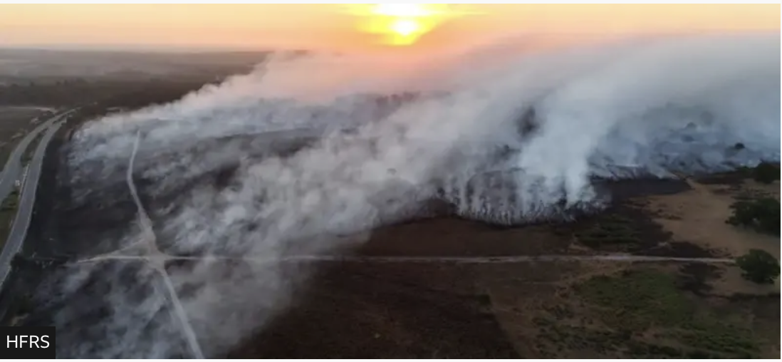
New Forest wildfire and the A31 closure
A vehicle fire near Poulner Hill on 9 August spread into the central reservation and surrounding New Forest heathland. The A31 was closed in both directions between the M27 and Ringwood while firefighters tackled the incident and National Highways assessed and repaired the road.
More than 120 firefighters were involved during the response. A five-mile water pipeline supplied around 1,300 litres of water a minute, while police drones helped crews monitor hotspots and flare-ups. Residents and motorists were repeatedly asked to keep access clear, avoid narrow Forest lanes and follow the official diversion via the A326, A35, A3060 and A338.
After almost two weeks, the A31 reopened. National Highways resurfaced the carriageway, installed 800 metres of new safety barrier and replaced 1,500 metres of boundary fencing. Temporary speed and lane restrictions remained while fire-damaged structures were protected and the emergency compound was cleared.
The reopening was a major relief for residents, businesses and motorists. My sincere thanks go to Hampshire and Isle of Wight Fire and Rescue Service, the crews who came from across the country, National Highways, Forestry England, the police, council teams, commoners, volunteers and everyone who supported the response. More than 100 hectares were affected, and the recovery of heathland, habitats and ancient trees will take many years.

Reporting Highway Problems
Links to report road issues are here:
Potholes: https://www.hants.gov.uk/transport/highways/report-a-problem/potholes
Tree/hedge problems: https://www.hants.gov.uk/transport/highways/report-a-problem/treehedge
Flooding/drainage issues: https://www.hants.gov.uk/transport/highways/report-a-problem/flooding
Pavement problems: https://www.hants.gov.uk/transport/highways/report-a-problem/paving
Broken or missing signs: https://www.hants.gov.uk/transport/highways/report-a-problem/brokensigns
Faulty street lights: https://www.hants.gov.uk/transport/highways/report-a-problem/streetlight
Faded or missing road markings: https://www.hants.gov.uk/transport/highways/report-a-problem/road-markings
Problems with rights of way: https://www.hants.gov.uk/landplanningandenvironment/rightsofway/reportaproblem
When reporting an issue, you’ll be sent an email confirming a reference number for the report. If you would like me to follow this up for you, please forward that message to me and I will chase it for you.
Hampshire and the Solent
Bringing more power and responsibility home
The Government has announced proposals for what it describes as the biggest transfer of power, funding and responsibility from Westminster in a generation. The direction is welcome: decisions should be made closer to the communities they affect, with local leaders given the flexibility to deliver rather than having to navigate repeated Whitehall approvals and short-term funding pots.
The proposals include:
- Mayors retaining a share of locally raised business rates from April 2027, followed by a share of income tax from 2028, with safeguards for areas with weaker tax bases.
- Greater local control over buses, integrated ticketing and commuter rail, with fewer Whitehall approvals for locally funded transport projects.
- Control over employment support and 16–19 skills funding so training can better reflect the needs of local employers and young people.
- More influence over housing, regeneration, affordable homes and development corporations.
- Greater coordination of health, policing, fire, education and support for young people, with more scope to pool budgets and invest in prevention.
The Government has also committed to improving council financial sustainability, including reform of the services placing the greatest pressure on local budgets: adult and children’s social care, homelessness and SEND. A detailed public-service reform white paper and fiscal-devolution roadmap are expected alongside the Budget on 28 October.
Hampshire and the Solent’s Combined County Authority already covers Hampshire, Portsmouth, Southampton and the Isle of Wight and has secured a £1.3 billion investment fund. We believe the mayoral election should be brought forward from 2028 to 2027 so residents can choose a directly elected regional voice as these new powers begin to take effect.

Children and Young People
A new three-year plan for SEND support
Hampshire County Council and NHS Hampshire and Isle of Wight have developed a new three-year plan with parent and carer forums, schools, education settings, health and social-care professionals and voluntary organisations. The aim is that every child receives the right support at the right time, wherever they live in Hampshire.
The plan includes:
- Earlier access to locally based specialists, including educational psychologists, occupational therapists, speech and language therapists and specialist teachers.
- More SEND provision in mainstream schools and greater consistency from early years through to age 25.
- Investment in local provision so more children can attend school in their own communities.
- A stronger voice for children, parents and carers in shaping services and resolving issues earlier.
Government funding of £9 million will help launch the new Experts at Hand service, giving education settings faster access to specialist support and advice. The plan is an important starting point, but success must be measured by the real experiences and outcomes of children and families.
Read more: https://www.hants.gov.uk/News/20260624sendreformplan
Results-day support through Hampshire Futures
We wished everyone receiving A-level results well and shared Hampshire Futures advice for anyone whose results were not what they expected. A disappointing set of grades does not close off the future: careers advice, employment, apprenticeships and alternative routes remain available, and Plan B is still a plan.
Careers information: https://www.hants.gov.uk/educationandlearning/hampshirefutures

Waste and Recycling Safety
Please recycle batteries and vapes safely
A recent fire in a Test Valley refuse-collection vehicle is believed to have been caused by a vape placed in household waste. Nobody was injured, but Hampshire and Isle of Wight Fire and Rescue Service had to attend. Lithium-ion batteries can ignite when crushed during collection, putting crews at risk and damaging vehicles.
- Never put batteries, vapes, mobile phones, laptops or other electrical items in household bins.
- Recycle batteries at participating supermarkets, retailers or Household Waste Recycling Centres.
- Take vapes to participating retailers or Household Waste Recycling Centres.
- Take phones, laptops and other electrical items to a Household Waste Recycling Centre.
Find local recycling options: https://www.hants.gov.uk/wasteandrecycling

Local Services and Business
Business-rates relief for pubs and live music venues
Eligible pubs and live music venues can receive 15% business-rates relief from 1 April 2026; the relief may not apply automatically, but any business that believes it qualifies and cannot see the relief on its bill should check the criteria and apply. The Government has also announced 20% relief from 1 April 2027, with detailed eligibility expected in the next Budget.
Check eligibility and apply: https://www.testvalley.gov.uk/business/land/business-rates/reliefs/pubs-and-live-music-venues-relief

General Updates from HCC:
Explore the best of Hampshire on board the bus this summer with free travel for 5–15-year-olds
Children aged 5-15 travelling on local bus services can travel free throughout August, making it easier and more affordable for families to enjoy days out in Hampshire, visit friends and relatives, or simply get around during the summer holidays
Explore the best of Hampshire on board the bus this summer with free travel for 5–15-year-olds | Hampshire County Council

Hampshire students receiving exam results offered free advice and support on next steps
Our level 2 and 3 exam results helpline is ready to take calls
Hampshire students receiving exam results offered free advice and support on next steps | Hampshire County Council

Help available for Hampshire households facing urgent costs
Hampshire residents who are struggling with urgent household costs are being encouraged to check what support may be available through the Crisis and Resilience Fund
Help available for Hampshire households facing urgent costs | Hampshire County Council

Queen Elizabeth Country Park celebrates 50 years with summer festivities
Queen Elizabeth Country Park near Petersfield is marking its 50th anniversary with an exciting programme of events this summer, including the opening of a brand-new children's play area
Queen Elizabeth Country Park celebrates 50 years with summer festivities | Hampshire County Council
Vote for Royal Victoria Chapel to become an ‘Everyday History Hero’ | Hampshire County Council

Hampshire students congratulated on Level 3 results as free careers helpline opens
Students across Hampshire receiving their A-level, T-level and vocational qualification results are being congratulated on their achievements, as support remains available for anyone considering their next steps
Hampshire students congratulated on Level 3 results as free careers helpline opens | Hampshire County Council

Funding available for local organisations helping Hampshire residents with money worries
Community and voluntary organisations across Hampshire are being encouraged to apply for funding to help residents build financial resilience and reduce the risk of future crisis
Funding available for local organisations helping Hampshire residents with money worries | Hampshire County Council

Cllr Rhydian Vaughan MBE
Member for Calleva Division
Hampshire & IOW Fire & Rescue Service
Hampshire County Council
Fb.com/tellrhydian
07774 681516

